**OS HOME ASSIGNMENT 1**

-Rujuta Shah(121044)

1. The output is as below :

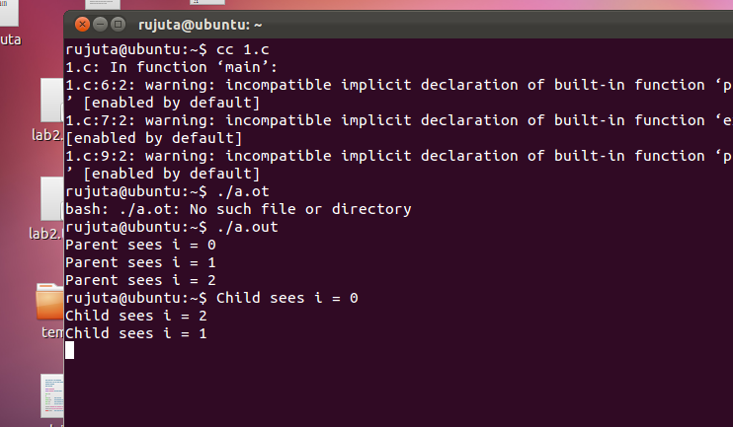

As we can see the parent process will be executed first.

2)

Parent says a: 1  
id: 2 a: 2 b: 1  
id: 1 a: 3 b: 1

3)

(1) User-level threads are unknown by the kernel, whereas the kernel is aware of kernel threads. (2) On systems using either M: 1 or M: N mapping, user threads are scheduled by the thread library and the kernel schedules kernel threads. (3) Kernel threads need not be associated with a process whereas every user thread belongs to a process. Kernel threads are generally more expensive to maintain than user threads as they must be represented with a kernel data structure.

4) m>n is the best possible solution.